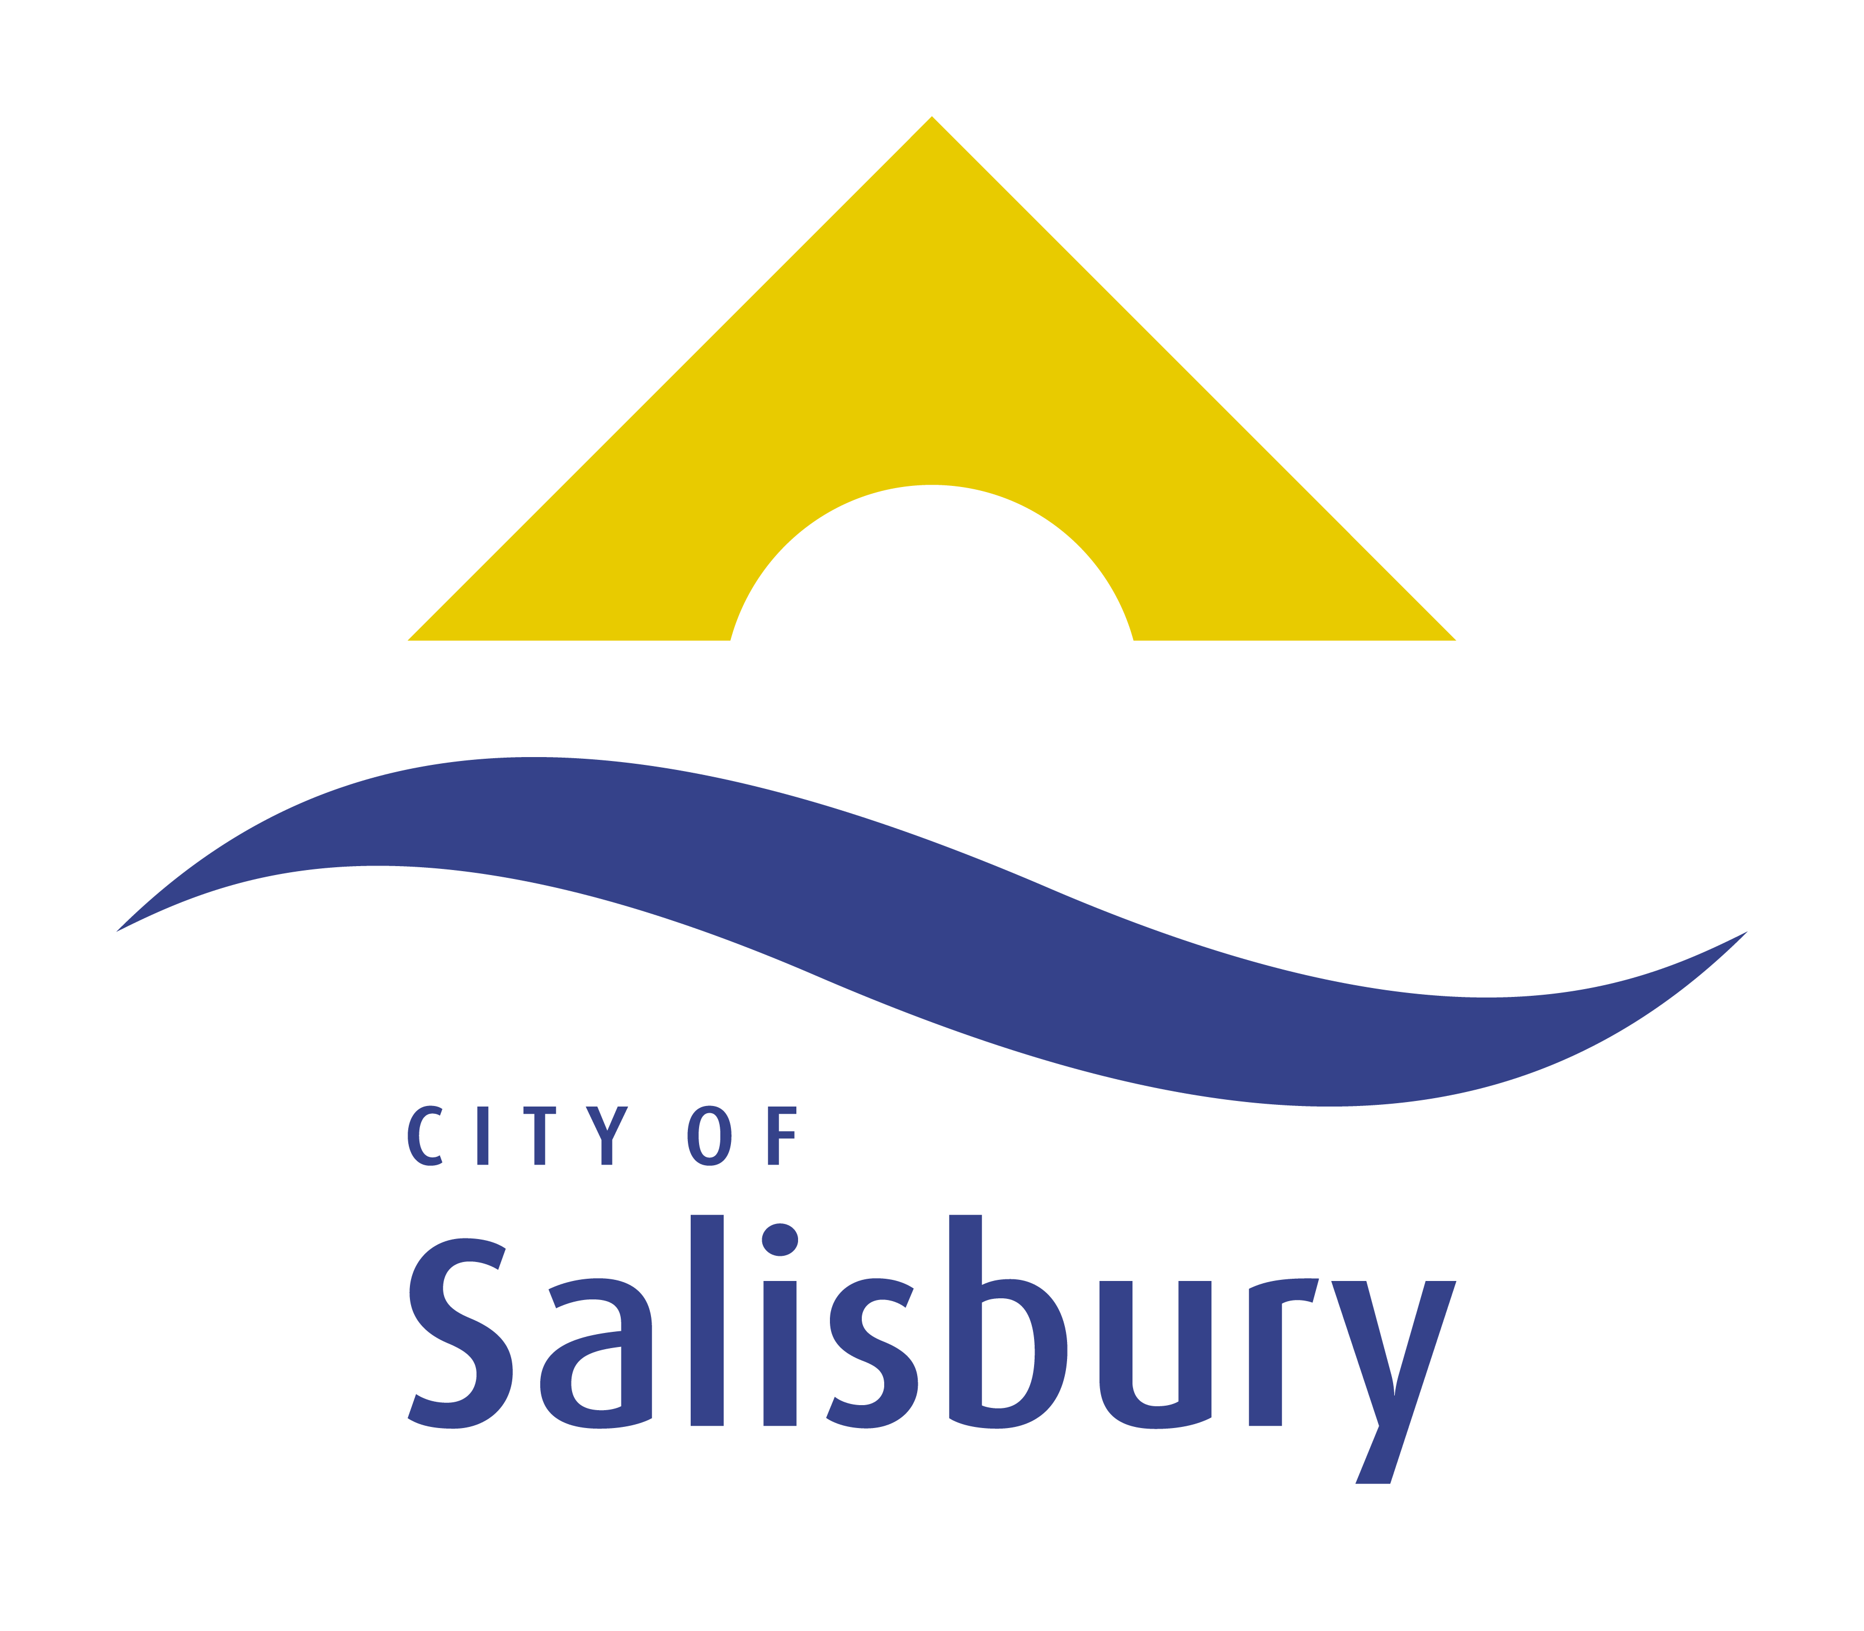
Community Event Sponsorship Program
Application Form

Before you begin
Before completing this application form you should read the Community Event Sponsorship Program – Guidelines and Eligibility Criteria booklet.
Making a valid application
- Use the form provided;
- Make sure you include all attachments and essential documentation where requested;
- Putting together a strong application takes time and energy, so it is important that you read the guidelines carefully, complete this application in full, and ensure that all of the information to be submitted with your application is provided;
- Applicants are encouraged to contact the Events team prior to submitting, an application to determine suitability for sponsorship;
- An information session will be held for potential applicants, please see the website for time and location;
- Have the Declaration section of the Application Form signed by two authorised representatives of the organisation; one signature must be the current President/Chairperson;
- Email, Post or personally deliver the completed application form with all of the essential supporting documentation to the City of Salisbury.
Address for submission of applications
Community Event Sponsorship Program
City of Salisbury
PO Box 8
SALISBURY SA 5108
city@salisbury.sa.gov.au

Essential Contact Information
It is essential that all applicants confirm the eligibility of projects prior to commencing their application.
All applicants must contact the Events Team to assess the eligibility of projects.
Phone 8406 8222 or Email city@salisbury.sa.gov.au

Information to be submitted with your application
 | Attached
Your most recent annual financial statement certified by the President /Treasurer or audited by a qualified accountant as presented at an AGM | ☐
A copy of Event Plan / Checklist | ☐
Where applicable supply evidence of cash support (e.g. recent bank statement) | ☐
Provide a Certificate of Incorporation demonstrating not-for profit status | ☐
Provide a signed copy of committee minutes endorsing the event, authorising an application to the Community Event Sponsorship Program and documenting the authorised project contact | ☐
Provide letters of support for the event (external parties to the organisers of the event) | ☐
Provide a letter/email from the head of the organisation supporting the application | ☐
Copy of Risk management plan | ☐
Copy of any quotes for contractors/furniture hire | ☐
Copy of approval of venue location | ☐
If event is for over 200 participants a confirmation of obtaining a Traffic Management Plan is required | ☐
Copy of Park/ Venue permit (obtained from council if on council owned property) | ☐

IMPORTANT
Incomplete applications will be considered non-compliant and ineligible for sponsorship. The applicant will be provided advice and requested to supply any outstanding documentation. Once all documentation has been received, the application will be processed and presented for assessment.
Organisation Information
- GROUP / ORGANISATION DETAILS
Name of the organisation:
As it appears on the Certificate of Incorporation
ASIC Registration Number: |  | (if applicable)
ABN:
Facility Name/Address:
Postal Address:
Registered postal address of the organisation
Suburb: |  |  |  |  |  | Postcode:
- CONTACT PERSON DETAILS
Person Responsible for the Sponsorship:  (all communication will be directed to this person) |  | Mr ☐ Mrs ☐ Ms ☐ Dr ☐ Other ☐:
Title / Office:
Phone: |  | Landline:  Mobile:
Email:
Please use an e-mail address that will be checked regularly.
- ABOUT YOUR TARGET AUDIENCE
Age: |  | Primary: |  |  | Secondary:
What percentage (%) of your target population reside in City of Salisbury |  | %
Anticipated attendance number:
- ABOUT YOUR ORGANISATION’S ABILITY AND EXPERIENCE
What events has your organisation held before? |  | Name of Event: | Year held: |  |  |  |  | Number of attendees:
Sponsorship
- SPONSORSHIP CATEGORY (Please select one only)
up to $5,000  Organisations planning to host an event within the City of Salisbury boundaries may apply for Community Event Sponsorship. |  |  |  |  |  |  |  |  | ☐
up to $10,000  Organisations planning to host an event within the City of Salisbury boundaries may apply for Community Event Sponsorship. |  |  |  |  |  |  |  |  | ☐
Have you sought, or intend to seek funds from another source to assist with this project?  (If Yes – Where from and the amount of sponsorship requested) |  |  |  |  |  |  | Yes ☐ |  | No ☐
Other funding Source/s: |  |  |  |  |  |  | Amount/s:
About the Event
- Event DETAILS
Name of Event:
Date of Event:
Location of Event:
Has your organisation held this event before in previous years? | Yes ☐ No ☐
If yes to the above, please provide dates of previous events:
Brief description of your Event?
Describe what you are planning

Why is the event needed?
Eg. Does the proposed event:
- increase participation opportunities
- provide additional avenue for revenue
- add to community and cultural life within the City of Salisbury

About the Event
How will your event increase participation opportunities for community and economic development?
Eg. Does the proposed event:
- address a gap in community participation / activation
- allow the event to increase economic opportunities
-Are you opening it up to the broader community?
Apart from Facebook, how will you promote and advertise the Event?
Apart from your organisation and its members, are there any other groups / businesses that will benefit from the event? Not just financially  Attach letters of support where applicable | Community Group / Business |  |  | How they will benefit
**Events seeking over $10,000**
What is the regional or state-wide significance of this event?
Why do you think the event is needed?
**Events seeking over $10,000**
What is the long-term vision and sustainability of the event in the City of Salisbury?
Do you plan to hold this event annually/biannual etc?

Budget Information
- USING THE HEADINGS IN THE TABLE BELOW, OUTLINE THE COST OF YOUR EVENT – ALL AMOUNTS ARE TO BE GST INCLUSIVE
Item | Amount | Quote Used
e.g. Marquee / Furniture Hire | $1,500 | e.g. Rotary / Atlas Hire
a. Total Event Cost | $
b. Your Contribution | $
c. Other funds secured (other sponsorship) | $
Total Sponsorship Requested (= a – b – c) | $

Terms and Conditions of Sponsorship
All applications are administered according to the following conditions.
- CESP funding will be used expressly for the purpose outlined in the application and as endorsed by Council. Requests to change the purpose of sponsorship must be made in writing and is at the discretion of the Council.
- A risk management plan will be completed and adhered to.
- City of Salisbury is not responsible for any budget shortfalls relating to inflation of costs and unanticipated works.
- City of Salisbury is not responsible for any loss or expense endured during event planning and implementation or in relation to the completed event.
- Please note that if your organisation’s annual turnover is greater than $150,000 (non-profit organisations) then you are required by the Australian Tax Office to be registered for the GST.
- Successful applicants who are registered for GST will have their grant grossed up by 10% to offset the GST payable on the grant.
- Organisations that are not registered for the GST will not have the grant grossed up.
- If successful, organisations cannot have their Grant Agreement transferred to another body on the basis of GST registration.
- A project acquittal must be submitted within twelve (12) months of project completion. Failure to supply proof of expenditure will result in ineligibility for future grant sponsorship.
- Unspent funds are to be returned to City of Salisbury.
- The City of Salisbury will be recognised as a major sponsor of the event in all media, speeches, MC notes and programming (noting any use of logos must be approved by the City of Salisbury communications and customer relations team).

We agree to abide by the terms and conditions of sponsorship | Yes ☐
Application Declaration
Please note that this declaration must be signed by two authorised representatives of the organisation; one signature must be the current President/Chairperson
On behalf of (Group/Organisation)

(Name/Position) (Name/Position)

(Signature) (Signature)

(Date) (Date)

Declare that I am authorised to complete this application on behalf of the applying community organisation and that the information contained in this application to the Community Event Sponsorship Program is accurate at the date of submission, and that the application is eligible for consideration under the guidelines and specifications of the program. Further we accept the terms and conditions upon which sponsorship for this project is offered.

